Fox Mercado Mall
5515 Alameda Ave
Starting at 100 sqft

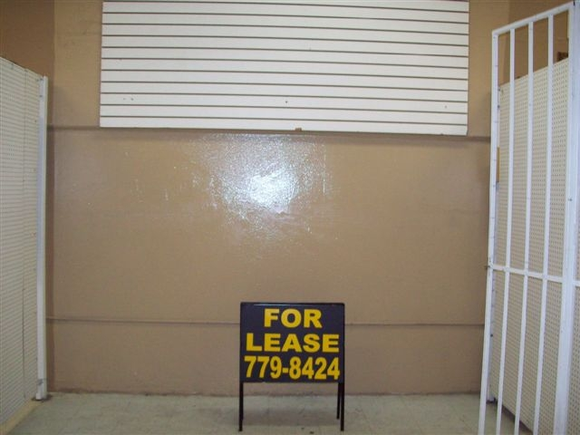


PROPERTY DESCRIPTION:
- Ready to move in!!
- Starting at $230 a month
- Month to Month Contracts
- Open 7 days a week
- High Traffic Shopping Center
- Expand your business

Contact Information:
On-Site Management & Leasing:
Vanessa Reyes or Jeannette Negrete
915-779-8424
www.foxplazamercado.com

